**Installation related**

**Warning: 1 Do not use a high torque electric screwdriver for installation, which will cause screw damage**

**2. Please be careful during installation to avoid damage to the positioning plate and electronic components**

**3. If there is a problem, please check this document or contact the vendor for solution.**

**4. If you suddenly have an extra KSTARORION U disk on your computer, please plug and unplug the receiver again and follow the instructions for upgrading firmware.**

1. **How to install orion87？**

A: Please contact your vendor to provide the installation video

Youtube：https://youtu.be/iRhH629l7m0

1. **Why does the key cap touch the screw？**

A：

1. When installing the screws, press the upper cover tightly to make the upper cover stick with the lower cover and install the screws in place.

2. If you use special OEM height key caps, you can solve it by canceling the back rubber foam above the positioning plate, which will also give you a more elastic feel. (if you use the aluminum locating plate, this may cause wear between the locating plate and the upper shell).

1. **Why is the spacing between the key cap and the shell inconsistent?**

A:

1. Please check whether your bottom foam is installed correctly.

2. Before installing the screw, you can manually adjust the position of the inner tank to center the key cap.

1. **How to use mounting screws？**

A：

Please try not to use electric screwdriver with large torque to avoid screw damage

H1.5 can be used for socket head cap screws Installation of screwdriver head

When installing screws, please control the force to avoid damaging the screws

1. **How to install foam？**

A：

1. Follow the installation video instructions to install the foam

2. The foam inside the bottom shell is installed vertically on the side of the bottom shell rather than horizontally

3. When installing the positioning plate, please stick the foam in the positioning plate as far as possible and do not exceed the boundary of the positioning plate

**6. How to install the cable？**

A：

1. First, pull out the black paddle of the corresponding socket of the PCB. Do not pull out the paddle.

2. Please insert the silver side of the flat cable into the socket and confirm that it is inserted to the bottom

3. Cover the black paddle

4. Confirm that the cable arrangement is parallel to the socket

5. Pull the cable in the opposite direction to confirm whether the installation is normal.

**7. Can I disassemble the logo？**

A：

Do not disassemble the logo, which will damage the logo screw

**8. Why does the shaft at the space bar come out of the locating plate？**

A：

If the axle body used more times is not firmly clamped, it will come out of the positioning plate.

You can cut a gap of about 18mm above the locating plate nearest to the shaft, which will not affect your use.

**9. Can the protective film of PVD counterweight be removed?**

A：

We do not recommend this, which will increase the risk of surface damage to the counterweight.

**10. Can I cut the shape of PORON cotton？**

A：

You can tailor it according to your preferences to adjust different hand feel and sound.

**11. Why is my key cap crooked？**

A：

1. Please check whether your shaft is aging and loose.

2. Please check whether the shaft body interferes with the PORON cotton.

**12. What if the shaft body and the screw column cannot be installed in place?**

A：

You can use the latest shaft of TTC and Kaihua to avoid this problem, or cut off the touched shaft edge to solve it.

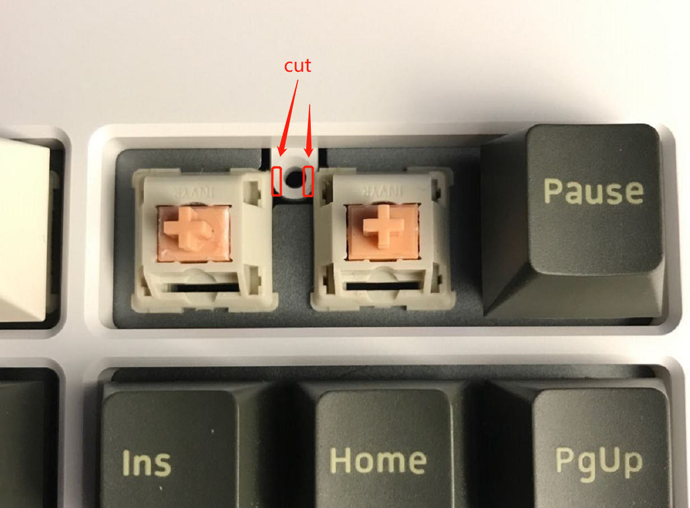

**Use related**

1. **Why my keyboard can’t use wired mode?**

A：

1. Please check whether the data cable supports the charging function

2. Please check whether the cable is dropped

3. Please check whether the cable is inserted askew

**2. Why my Bluetooth function can’t work?**

A：

1. Refer to question 1 and check that the battery is installed correctly

2. Your battery may be low

3. Please confirm whether your current channel is connected to other devices

4. Please confirm whether your device supports Bluetooth 5.0 protocol

**3. Why my 2.4G function can’t work？**

A：

1. Please check whether the receiver is plugged into the computer correctly. If you see the receiver device, it proves that the receiver function is normal.

In win system, you can find Orion receiver by viewing settings - devices - Bluetooth and other devices. If there is no such device, please check whether the USB port is normal

MAC&Linux，please check whether there is a device named Orion Receiver through the USB interface device

2. If your receiver displays that the installation is normal, but you cannot use the keyboard through FN + 7 key combination, please check whether the keyboard is powered.

3. If 1 and 2 are displayed normally, it means that your receiver firmware is inconsistent with the keyboard firmware. Please brush the keyboard firmware to match the receiver according to the brushing guide provided by us.

4. If 1, 2 and 3 cannot solve your problem, please contact the seller to replace the receiver.

**4. Is there a delay in wireless mode？**

Due to the shielding effect of the metal shell on the signal, there will be a delay in the wireless mode. You can adjust the relative position between the receiver and the keyboard to get a better signal.

**5. In wireless mode, the key is always output.**

A:

Please click the button with multiple hits again. This is because your device signal is poor, resulting in the loss of information.

**6. Why there is a component in PCB very hot？**

A：

Because RGB lamp beads consume a lot of power and have a large current, this component will be hot. This is a normal phenomenon. You can reduce its temperature by turning off the lamp.

**7. How to obtain better wireless signal?**

A：

You can debug the signal by adjusting the position between the receiver and the keyboard. Generally, the receiver is higher than the upper surface of the keyboard, and there is no metal barrier between the receiver and the keyboard, which will obtain good signal quality.

**8. How long can the battery stand by？**

A:

When the light is off, the battery can stand by for 3 months

When the light is on, the battery can stand by for 2 days.

**9. How do I turn off the keyboard immediately？**

A：

Press FN + pause to close the keyboard, and click any key to wake up the keyboard

**10. How to turn off the light？**

A：

Press FN + L to turn the lights off or on

**11. What if the keyboard crashes?**

A：

1. Please confirm whether the keyboard is in brush mode. If there is an extra one named key in your computer KEYStar USB flash disk, which proves that you are now in brush mode. You can solve this problem by completely powering off or swiping in the firmware

2. If it is not case 1, please use it after completely powering off (this includes unplugging the data cable and battery)

**12. Why I can’t change RGB mode when my light is only white？**

A：

Please adjust the saturation and hue of the light to other colors before operation.

**13. Why is only one blue light on my keyboard？**

A：This indicates the connection status of the keyboard. If you need to turn on the light, press FN + L switch

**14. Why isn't my keyboard light on?**

A：Your keyboard light brightness is set too low or turned off. You can turn on the light through FN + L. if this is invalid, press FN + up to increase the brightness of the keyboard backlight.

**15. Why does my keyboard light flash suddenly?**

A：The power of your keyboard is too low. Please charge it in time.

**16. How to check the battery power?**

A: Connect the device via Bluetooth or 2.4G and check the battery power on the device related settings page.

**17. Does the keyboard support Linux and MAC systems?**

Yes, this keyboard supports most commonly used operating systems at present, but some minority versions of Linux do not support USB, so this keyboard cannot be recognized. If unrecognized, please update the USB driver of the system.

**Update Firmware**

**At present, the firmware is constantly upgrading. We provide a stable version of firmware. If you find that the keyboard enters the brush mode, you can brush and write this version of firmware first. Let's start!**

**The receiver must be brushed in first, otherwise the receiver will not be available**

receiver firmware

[orion-receiver-feature-v1.3.0-beta7-2021-12-23-23.uf2](https://cdn.discordapp.com/attachments/924333992537370685/924506965051318343/orion-receiver-feature-v1.3.0-beta7-2021-12-23-23.uf2)

143.50 KB

1. insert the 2.4G receiver

2.FN + 7 enable 2.4G mode

3.Test whether 2.4G is available

4.If 2.4G is available, press FN + backspace to turn on the 2.4G receiver brush mode

5.Your computer will pop up a U disk，（Please do not move or delete the files on this U disk）

6.Copy the uF2 file with the file name ‘’receiver‘’ to the U disk

7.The receiver will automatically brush the machine, and the U disk will disappear automatically after completion

8.Please note that the firmware with default character in the name cannot be brushed in

9.Unplug the receiver again, then insert the receiver

10.At this time, the 2.4G receiver has finished brushing, and the original motherboard will not be able to connect to the receiver

Brush in motherboard firmware

pcb firmware

[keystar-orion-keyboard-default-feature-v1.3.0-beta7-2021-12-23-23.uf2](https://cdn.discordapp.com/attachments/924333992537370685/924507078427545610/keystar-orion-keyboard-default-feature-v1.3.0-beta7-2021-12-23-23.uf2)

244.50 KB

1.Insert the data cable into the keyboard, press FN + ~ to switch to wired mode, and test whether it is available.

2.Press FN + scroll lock to start the PCB brush mode

3.A new U disk will appear in the computer. Copy the uF2 file with default character to the U disk

4.The keyboard will automatically brush the machine, and the U disk will disappear automatically after the brush is completed

5.After the U disk disappears, press FN + ESC to restart the keyboard

6.Press FN + 0 to reset all wireless channels

7.Delete the original connection record on the device previously connected to the keyboard Bluetooth

8.On the device connected to the keyboard, unbind the keyboard Bluetooth. If the keyboard Bluetooth is not bound, this step can be ignored

9.Enjoy it

